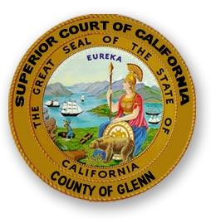
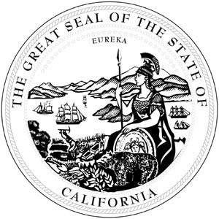

Superior Court of California, County of Glenn
Cindia Martinez
Interim Court Executive Officer ● Jury Commissioner

PRESS RELEASE

The Superior Court of California, County of Glenn is now accepting applications for the 2018-2019 Civil Grand Jury. Each year the Court is required by the California Constitution to impanel a grand jury. This body is mandated to investigate and report on both civil and criminal matters within the County.

The Grand Jury is comprised of citizen volunteers. Jurors need:

To be a good listener,

To commit to one full year of service,

To work with 18 others to reach a common goal,

To ask meaningful questions, review confidential documents and help write reports

To remain confidential

An interest in having direct involvement in government, while performing as a watchdog agency

To want to serve the community

In order to secure prospective Grand Jurors, seven hundred and fifty applications are now being sent to the citizens of Glenn County. This selection was made randomly from the voter registration and the Department of Motor Vehicle’s rolls. Any other interested Glenn County residents who did not receive one of these random applications are also encouraged to apply. This helps the Court create a diverse pool of applicants to be representative of the community of Glenn County.

Service on the Grand Jury is a very important duty that is essential to the successful administration of justice. The Court encourages all application recipients to serve their community and exercise their civic duty by participating in this vital and rewarding public process. Once the Grand Jury is impaneled, their meetings are held once a month as determined by the appointed jurors.

If you are interested in participating in the Grand Jury process and helping your community and did not receive an application or you need further information, please contact Ms. Karen Dura, Court Administrative Assistant, at 530-934-6382 or go to our web site at

http://www.glenncourt.ca.gov/court_info/grand_jury.html and print the application. Applications need to be received at the courthouse by April 20, 2018.

******************************************************
For further information contact: Karen Dura, Administrative Assistant
530-934-6382
526 West Sycamore Street
Willows, California 95988

